**SPRINT 4**

|  |  |
| --- | --- |
| Team ID | PNT2022TMID51155 |
| Project Name | Smart Fashion Recommender Application |

**UPLOADING IMAGE TO IBM CONTAINER REGISTRY:**

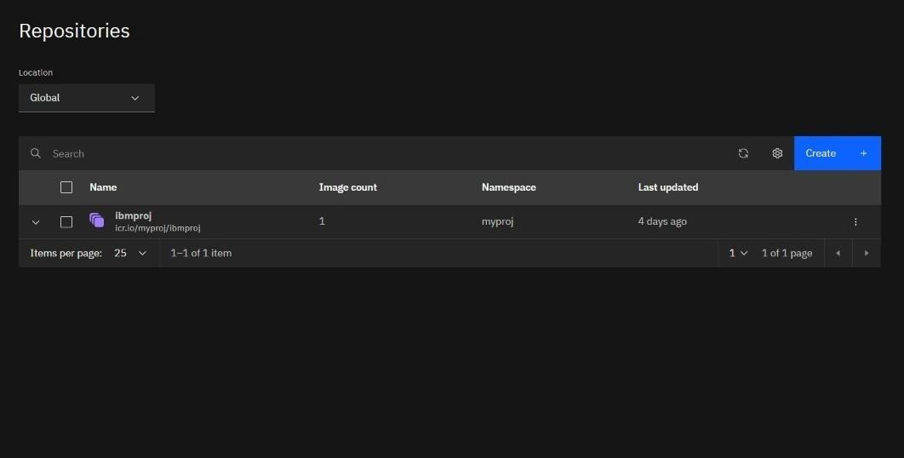

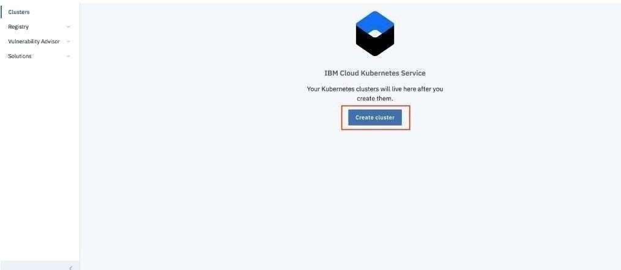

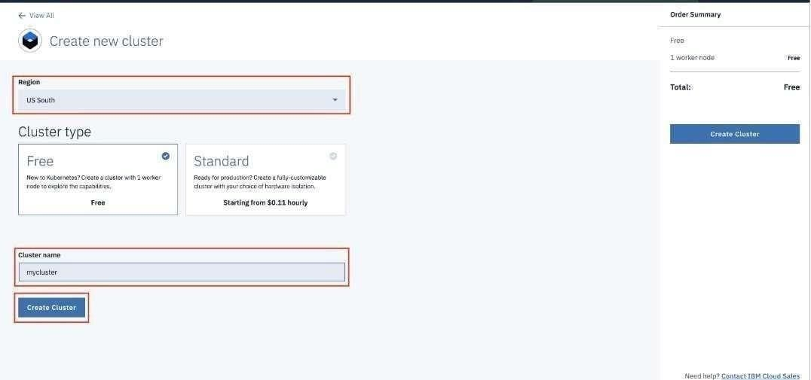

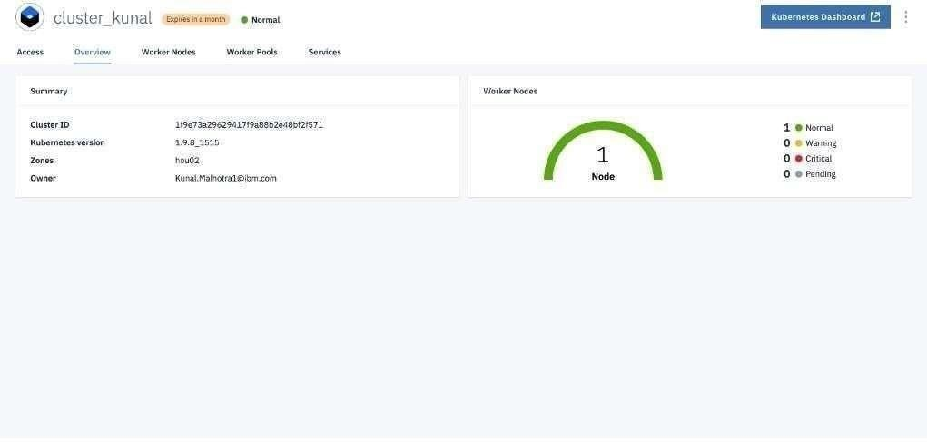

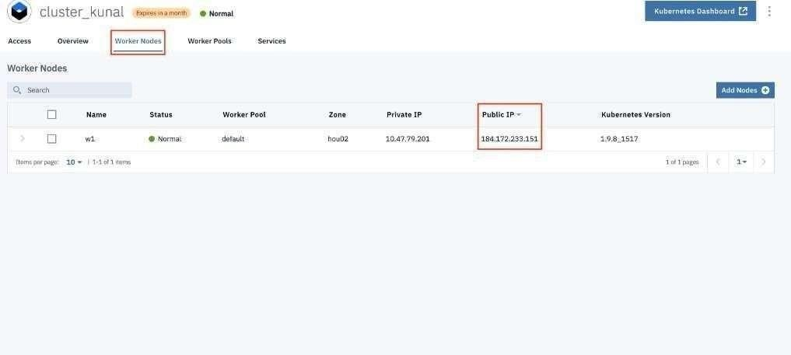

**DEPLOY IN KUBERNETES CLUSTER:**

